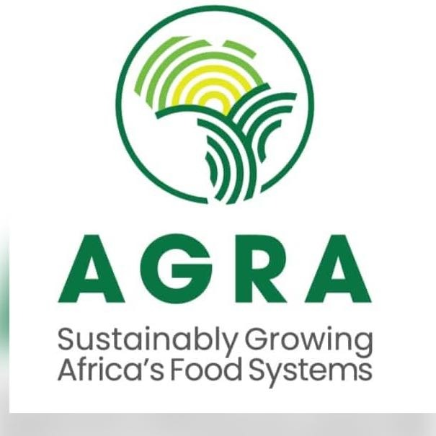

REQUEST FOR PROPOSAL

CONSULTANCY FOR A PRINT AND DESIGN CREATIVE AGENCY.

AGRA reserves the right to determine the structure of the process, number of short-listed participants, the right to withdraw from the proposal process, the right to change this timetable at any time without notice and reserves the right to withdraw this tender at any time, without prior notice and without liability to compensate and/or reimburse any party.

Synopsis of the Request for Proposal

Title Reference No | RFP/025/COMMS/2023
Reference Number | Consultancy for a Print and Design Creative Agency
Issuing Office & Address | AGRA  Website: www.agra.org
Contracting Office | AGRA Nairobi, Kenya
Point of contact for clarifications, questions and amendments | AGRA General Procurement,  Procurement@agra.org
Email Address for submission of Proposals/Quotes | AGRA General Procurement,  Procurement@agra.org
Solicitation Issue Date | 18th, April 2023
Confirmation of interest in this consultancy | Interested consultants/bidders are requested to register on the link below by close of business 21st, April 2023. Any additional communication will be shared with those that will have registered on the link below.  For Registration Link click: HERE
Deadline for submission of questions and clarifications | 21st, April 2023 ,1700 hours, East African Time
Deadline for Answering questions and clarifications | April 24th, 2023 ,1700 hours, East African Time
Deadline for Submission of Proposals | April 25th, 2023, 5:00PM, East African Time.  Please include the subject line “RFP/025/COMMS/2023” of the email.
Type of Consultant  Type of Consultant | Consultancy Firm
Type of Contract | Framework Agreement
Anticipated Award Type | Consultancy Agreement for a one-year contract, renewable twice.
Selection Method | Quality and Cost Based Selection (QCBS)
Eligibility | Firms registered in Kenya
Weight of Technical Vs Financial  Proposal | Technical proposal: 70%  Financial proposal: 30%
Submission Requirements and Evaluation Criteria | Mandatory Documents Required  - Trading license or Certificate of incorporation or Certificate of Registration  - Valid tax clearance certificate (Applicable to firms originating from Kenya, Rwanda, Ghana, Tanzania, and Mozambique).  Evaluation Criteria  - Organizational Capacity …......................................................10%  - Experience in similar assignments ……………………………………..50%  - Experience and Qualification of key personnel ….................40%  Total: …...................................................................................100%  NB.  - Minimum technical pass mark for technical evaluation is 75%  - AGRA will negotiate with the firm that attains the highest combined  technical and financial score.

- Background
Established in 2006, AGRA is an African-led and Africa-based institution that puts smallholder farmers at the center of the continent’s growing economy by transforming agriculture from a solitary struggle to survive into farming as a business that thrives. Together with our partners, we are working to sustainably grow Africa’s food systems.

AGRA strengthens seed systems, develops, and promotes sustainable farming practices, helps unlock trade and markets, and supports governments who lead their countries’ development. We work with farmers to adapt to climate change, increase soil health, and protect the environment. AGRA believes deeply in the urgency of reducing the inequality that women face in agriculture, and to unlocking the power and innovation of youth.

For more information about AGRA, visit our website: https://agra.org/.

- Objective

AGRA is looking for one to two creative design and print agency to create visual concepts to communicate AGRA’s ideas that will inspire, inform, and captivate our stakeholders and partners.

- Scope of Work

- Conceptualizing and producing layouts and designs and providing alternative proposals with three different concepts and designs for each item.
- Producing short animations, infographics, graphic designs for social media platforms, e-newsletters, mailers, power point presentations whilst following the design guidelines.
- Participating and providing inputs to preparatory meetings for new campaigns/initiatives.
- Designing the Public Relations products/merchandise.
- Producing graphic design/layout for AGRA project brochure, external report, and folders.

The firms are expected to submit the price quotation for creative Design and Print services as per below list of activities and rate card.
- Booklets/Newsletter: Designing contents up to 8 pages.
Size in inches | Pages | Estimated price | Estimated quantities
Up to 8.27* 11.69 | Up to 4 |  | 50
 | 5-8 |  | 40
Above 8.27* 11.69 | Up to 4 |  | 40
 | 5-8 |  | 20

- Report/ Booklets: Designing contents from 9 pages and up (up to 40 pages only)
Designing Contents including cover pages, tittle, and credit pages
Size in inches | Pages | Estimated price | Estimated quantities
Up to 8.27* 11.69 | 9-19 |  | 50
 | 20-40 |  | 30
Above 8.27* 11.69 | 9-19 |  | 40
 | 20-40 |  | 10

- Flyers/Leaflet: 1 Single sheet
Size in inches | Pages | Estimated price | Estimated quantities
Up to 8.27*11.69 | One side |  | 30
Above 8.27*11.69 | Both sides |  | 30

- Leaflets/Brochures/Facts sheets/Info sheets 4 pages to 12 pages (1 to 5 folds)
Size in inches | Pages | Estimated price | Estimated quantities
Up to 8.27* 11.69 | 4 (1-fold) |  | 30
Open | 6 (2 folds) |  | 30
Open | 8 (3 folds) |  | 30
Open | 10 (4 folds) |  | 30
Open | 12 (5 folds) |  | 30

- Posters
Size in inches | Pages | Estimated price | Estimated quantities
Up to 27.8* 39.4 | 1 |  | 100
Above 27.8* 39.8 | 1 |  | 100

- Folders
Size in inches | Pages | Estimated price | Estimated quantities
Up to 19.7* 27.8 | Up to 2 + pockets |  | 8

- Merchandise
Size | Estimated price | Estimated quantities
T shirts, jackets, hoodies and sleeves |  | 1

- Calendars

- Wall type calendars of wall chart
Sizes in inches | Artwork per page up to 17.5* 22.5 | Artwork per page above 17.5* 22.5 | Estimated quantities
1 individual page |  |  | 1
3 +1 (3 pages contents + 1 page cover) |  |  | 1
6 +1 (6 pages contents + 1 page’s cover+ |  |  | 1
12 + 1 (12 pages contents+ 1 page cover |  |  | 1

- Desk type calendars

Sizes in inches | Artwork per page up to 17.5* 22.5 | Artwork per page above 17.5* 22.5 | Estimated quantities
1 individual page |  |  | 1
6 +1 (6 pages contents + 1 page’s cover+ |  |  | 1
12 + 1 (12 pages contents+ 1 page cover |  |  | 1

- Creation of Social Media post (photos +typo)
Size in inches | Estimated price | Estimated quantities
Open |  | 200

- Creation of logos
Type | Estimated price | Estimated quantities
Level 1: typographical only |  | 1
Level2: typo+ light symbol |  | 1

- Required skills and experience.

- The firm should have been in operation for the last five (5) years, with proven experience in creative agency work / similar services regionally and internationally.
- The firm should have core staff with a minimum of five years of creative/ design/ print experience with similar clients.
- Experience with development work projects is an added advantage.
- Have good knowledge and skills in design/DTP will be a strong added advantage.
- Strong theoretical and practical background in graphic design, including the use of design software such as Adobe Design Premium, In-Design, CorelDraw, Final Cut HD, web design tools such as Dreamweaver and Flash, etc.
- Knowledge of standard software packages, including MS Office– MS Access–MS Visio Adobe Acrobat.
- Qualities
    - Experience working with different levels of business leaders/representatives.
    - Flexible and agile – demonstrated ability to work within tight deadlines and attend to urgent briefs, work from anywhere.
- References
    - Firms must submit at least 2 references from previous and current clients who can attest to the quality of work.
- Quality Assurance
    - Must demonstrate having a quality assurance process in place.
- Duration
The assignment will last for a period of Twelve (12) months, AGRA will sign a framework contract with successful firm(s) and work will be assigned on a need basis.
- Institutional Arrangement and Reporting
In carrying out this assignment, the consultant will be supervised directly by AGRA represented by the Senior Communications Officer and will work closely with Communications team and other relevant members of AGRA.

- Selection Criteria

Interested firms shall be evaluated against the following technical criteria:
  - Organizational Capacity …...................................................................................................10%
- Company profile, company accreditations and certifications.
  - Experience in similar assignments …….............................................................................50%
- Meet requirements as outlined under experience of the firm.
- Share list and description of similar assignments carried out, including client contact details and dates when the assignment was carried out.
- Firms must submit at least 4 references from previous/current clients who can attest to this quality of work.
  - Experience and Qualifications of key personnel…......................................................40%
- Degree or Diploma graphic Design, Fine Arts.

Total Score…............................................................................... ..........................100%

Note:
- Minimum technical score – 75%
- Method is Quality and Cost Based Selection (QCBS)
- Weightage; Technical proposal - 70% and financial proposal - 30%.

- Copyright
All materials / documents arising out of this consultancy work shall remain the property of AGRA.
- Application Submission Requirements
- Technical Proposal
    - Company profile, Certifications, and accreditations.
    - Share list and description of similar assignments carried out, including client contact details and dates when the assignment was carried out.
    - Firms must submit at least 4 references from previous/current clients.
    - Proposed key staff, their roles including their CVs, academic and professional certificates.
    - The technical proposal should be comprehensive yet brief e.g., in PowerPoint. CVs, copies of academic certificates and other supporting documentation may be attached as annexes.
- Financial Proposal
- The firm shall provide a financial proposal for carrying out the assignment. The breakdown of total fees per rate card provided above.
- Professional fees shall include the applicable VAT and withholding tax.
- If the financial proposal is silent on taxes, AGRA shall assume that these are inclusive.
- Prices must be quoted in USD ($). Contracting will be in USD and bidders are encouraged to have a USD bank account.

    - GUIDELINES FOR PREPARATIONS AND SUBMISSION OF PROPOSALS
- The Proposals shall be prepared in English Language.
- The proposals SHALL be submitted to procurement@agra.org. by the deadline indicated in the synopsis.
- The technical proposal shall not exceed 20 pages.
- The proposal and ALL Attachments submitted via email SHALL NOT exceed 10MB.
- VALIDITY of the proposal shall be for a period of 90 days from the date of bid closure.
- Financial proposal shall be sent as a separate attachment and MUST be password protected. The password shall be requested from the firm that meet the best technical score above 75%.

